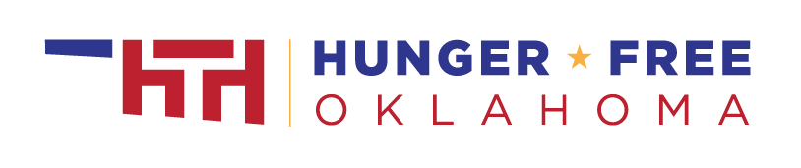
P-EBT Sample Facebook/Twitter Post:
Did your child receive free or reduced-price school meals in the spring 2020 semester? Pandemic EBT provides families financial support to cover the cost of groceries due to your children missing meals during school closures this spring. Learn more – www.hungerfreeok.org/pebt
P-EBT Sample Text Message:
Did your child receive free or reduced-price school meals during the spring 2020 semester? Pandemic EBT provides families financial support to cover the cost of groceries due to your children missing meals during school closures this spring. Learn more here – www.hungerfreeok.org/pebt
P-EBT Robo Call Script 1:
Hello! This is [share Name/Title/Organization] If your child received free or reduced-price school meals during the spring 2020 semester you may be eligible for a Pandemic Electronic Benefits Transfer card, or P-EBT card. P-EBT provides up to $250 per eligible child to help your household replace meals lost due to school closures. To learn more, visit www-dot-hungerfree-o-k-dot-o-r-g-forward slash-p-e-b-t . Thank you!
P-EBT Robo Call Script 2:
Hello [school/organization name] families! This is [title, name] calling to let you know about an important resource to help families who are struggling because of the pandemic. If your child was eating free or reduced-price school lunch in March 2020, you are eligible for food purchasing assistance of $250 per eligible child.
The Oklahoma Department of Human Services will be sending Pandemic Electronic Benefits Transfer benefits, or P-EBT, to eligible families – you do not need to apply. If you already have an EBT card the benefits will be loaded on your existing card. If you do not currently have an EBT card, please look out for a P-EBT card in the mail. Watch closely as the outside envelope may not clearly say P-EBT.
P-EBT is available to any child who was receiving free or reduced-price school lunch in March 2020. It will not impact your citizenship or immigration status.
To learn more, visit www-dot-hungerfree-o-k-dot-o-r-g-forward slash-p-e-b-t . Thank you!
P-EBT Sample App Message or Website Banner:
Did your child receive free or reduced-price school meals during the spring 2020 semester? Pandemic EBT provides families financial support to cover the cost of groceries due to your children missing meals during school closures this spring. Learn more here – www.hungerfreeok.org/pebt
Email/Letter Template:
Subject Line: Pandemic Benefits Can Help You Buy Food
Body:
Hello [school/organization name] families!
We are writing to let you know about an important resource to help families who are struggling because of the pandemic. If your child was eating free or reduced-price lunch school lunch in March 2020, you are eligible for food purchasing assistance of $250 per eligible child!
The Oklahoma Department of Human Services will be sending Pandemic Electronic Benefits Transfer benefits, or P-EBT, to eligible families – you do not need to apply. If you already have an EBT card the benefits will be loaded on your existing card. If you do not currently have an EBT card, please look out for a P-EBT card in the mail. Watch closely as the outside envelope may not clearly say P-EBT.
P-EBT is provided to any child who was receiving free or reduced-price school lunch in March 2020. It will not impact your citizenship or immigration status.
To learn more, visit www.hungerfreeok.org/pebt. Thank you!

