Partner Request Template for SNAP HOTLINE:

Subject Line: Please join us in sharing new food resource

Greetings!
COVID-19 has changed our world and increased the need for more coordinated resource sharing and communications. With changes to income for many in our community, we request your help to share a new resource to help protect and improve food security for our community friends and neighbors.

Please join us in telling others:
- There is a new statewide SNAP application HOTLINE to help Oklahomans connect to SNAP.
- To apply by phone call toll free 1 (877) 760-0114 between 8 a.m. and 8 p.m., daily.
- To learn more, visit: www.hungerfreeok.org/groceries.

Hunger Free Oklahoma offers support and resources to connect Oklahomans in need to food resources.
For free templates, graphics, and material to make sharing the SNAP HOTLINE easy please visit https://hungerfreeok.org/school-resources/#snap-access.

Why sharing SNAP matters:
Connecting families to SNAP is good for students, communities, and schools.

Here’s how:
- SNAP is proven to improve household food security, nutritional outcomes, and reduce health care costs. To learn more click here.
- SNAP helps local economies and supports small business.
- SNAP acts as an automatic stabilizer during economic downturns. Read more
- Student SNAP participation is the biggest contributor to a school’s direct certification rate and other measures to determine area needs which can connect low-income students with school meal benefits and increase opportunities to offer free breakfast and lunch to all students during the school year.

We appreciate your help in sharing this important food resource with our community.
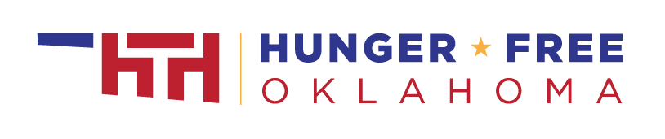
Regards,

