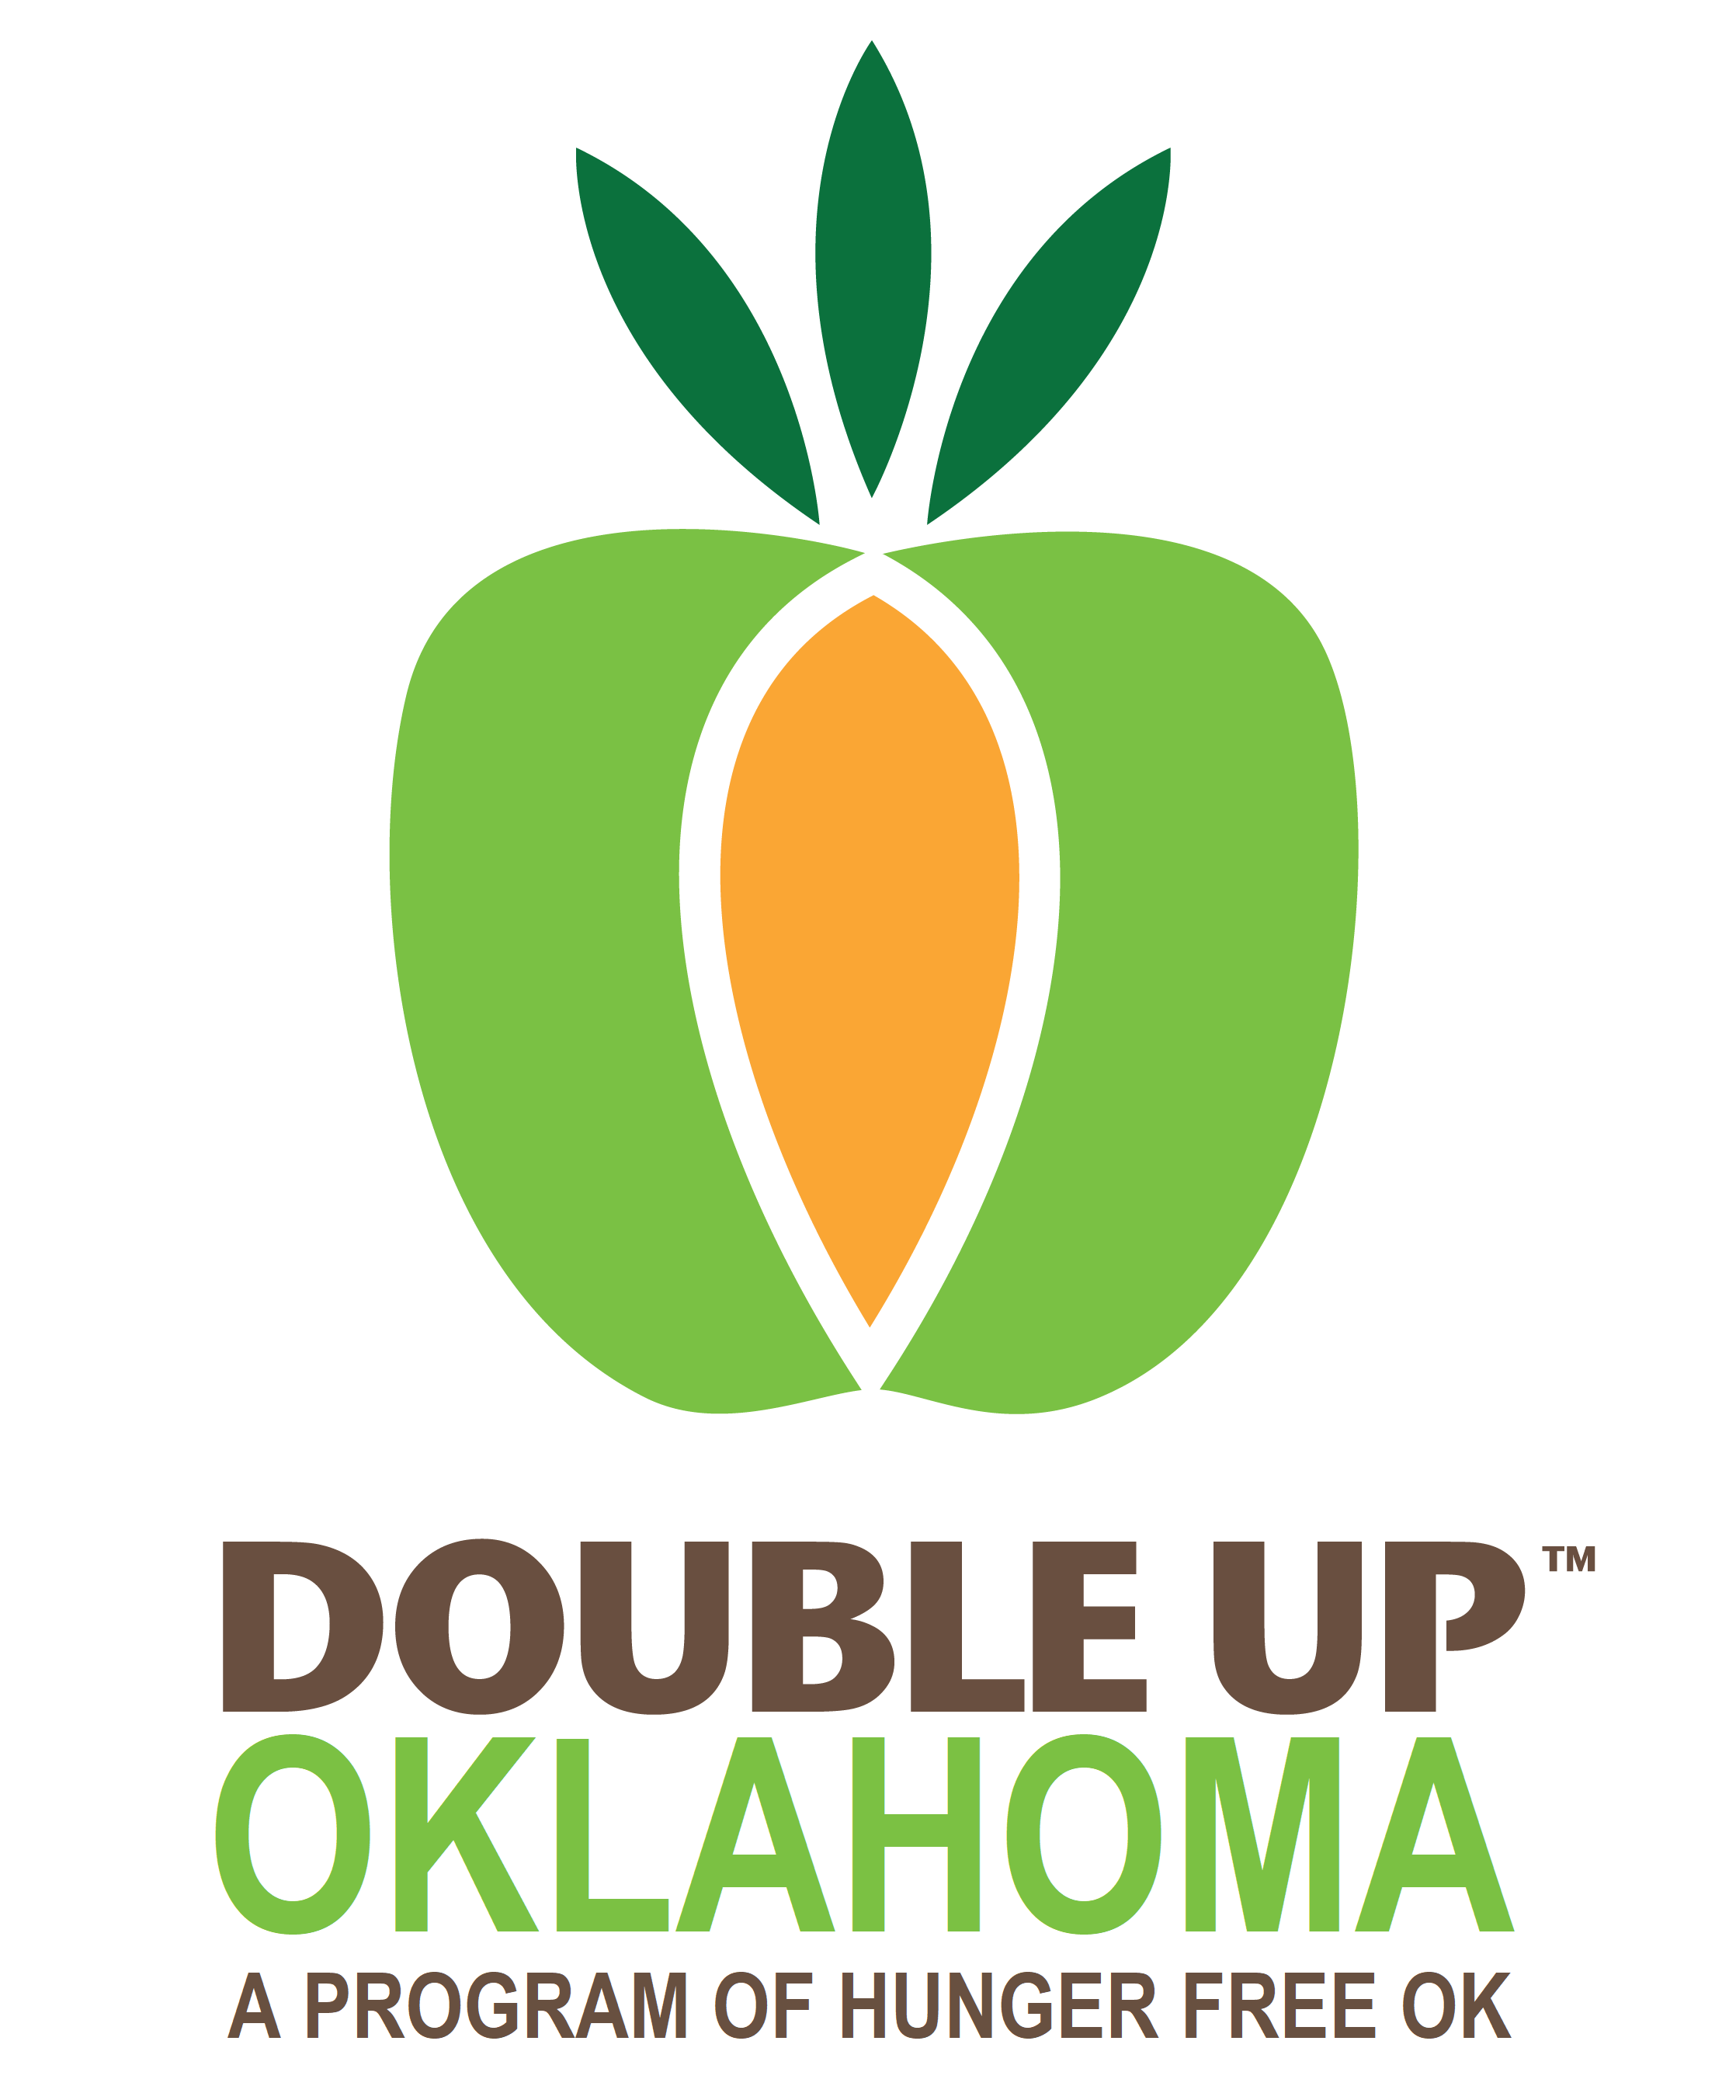

Double Up Oklahoma

Farmers Market

Application Guide

February 12, 2020

