Thurman J. White Forum Building Map
University of Oklahoma
1704 Asp Ave, Norman, OK 73072

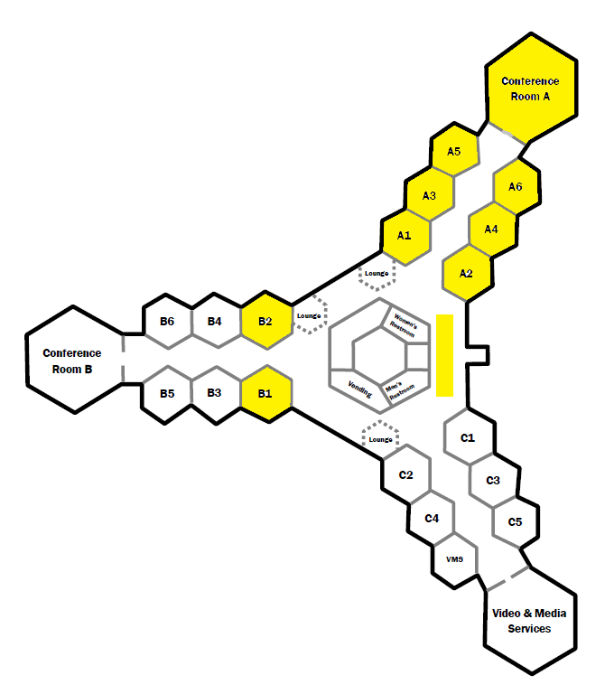
To parking and shuttle bus
Registration

