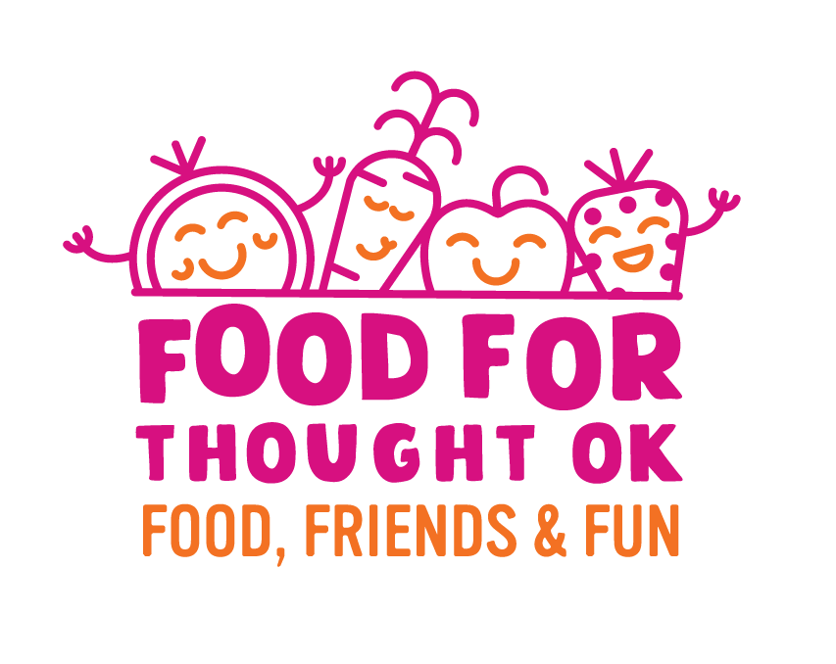
Summer Meals Outreach – Social Media

Email Subject Line: Let’s fight childhood hunger together this summer

According to the U.S. Department of Agriculture, more than 12 million children in the United States live in food insecure homes, meaning they are part of families who do not regularly have enough food to eat. While many children rely on food programs during the school year, six out of seven hungry kids do not get the meals they need during the summer months when school is out of session.

We believe every child is entitled to safe, nutritious food, and are dedicated to providing no-cost meals and activities for kids ages 18 and younger. With sites across Oklahoma taking part in this year’s Food for Thought OK Summer Meals Program, we are committed to our goal of no child going hungry this summer.

Join our fight against childhood hunger and show your support of Food for Thought OK by sharing the social media content below on your own channels. Together, we can work to ensure none of Oklahoma’s children have to worry about where they will get their next meal.

Post 1:
We're gearing up for this year's #FoodForThoughtOK Summer Meals Program! Sites all across Oklahoma will be providing no-cost meals and activities for kids ages 18 and younger all summer long. Learn more: www.Meals4KidsOK.org.
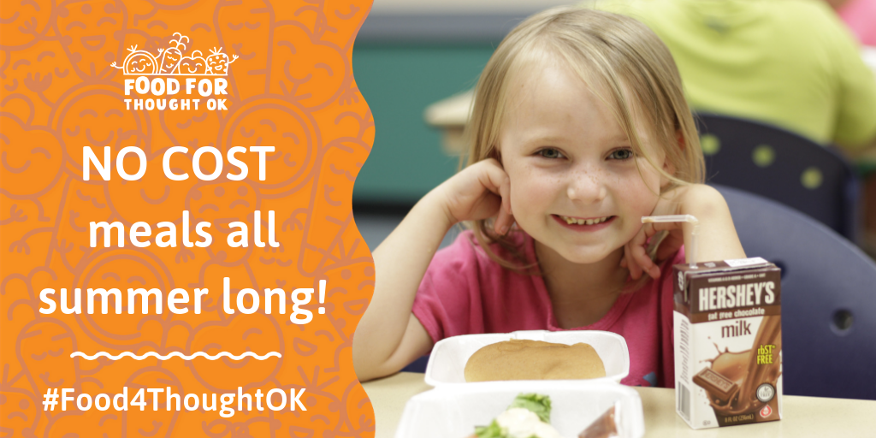

Post 2:
FAMILIES: Did you know kids 18 years and younger can enjoy no-cost meals this summer? Visit www.Meals4KidsOK.org to find your nearest summer meal site! #Food4ThoughtOK

